**Mean of a Data Matrix**:

In this we take mean of each feature for a new vector called mean vector.

Example for iris we take mean of each feature [SL, SW, PL, PW] and therefore we get 4 means and finally with this 4 means we get a mean vector. This mean vector says the **central value** of the whole datapoints.

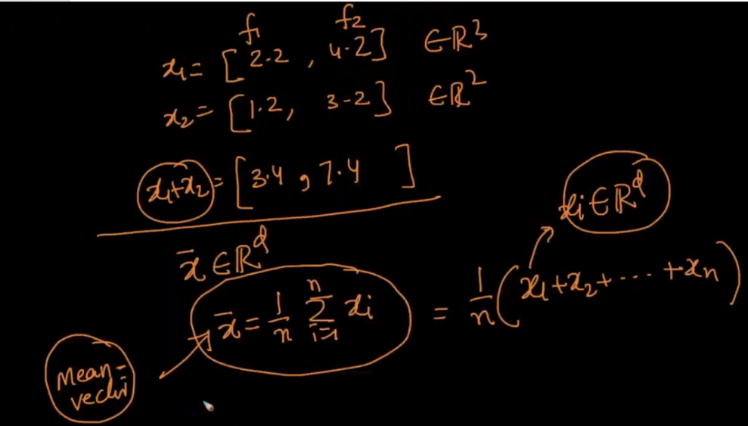

Below image shows example for height and weight features and finding mean vector.

